
UV Water Sterilizer
40 Watt
- Introduction
Thank you for choosing our Elitech UV Water Sterilizer 40 Watt. Please read the manual carefully before operating and retain it for future use. The manufacturer reserves the right to revise or change anything as needed without prior notice.
This manual will help you better understand the operation and maintenance of the product. It is reminded that the product must be used strictly in accordance with this manual. User operation that fails to comply with this manual may result in damage or accidents for which PT. SINKO PRIMA ALLOY. (hereinafter referred to as PT. SINKO PRIMA ALLOY) cannot be held responsible.
PT. SINKO PRIMA ALLOY owns the copyright to this manual. Without the written consent of PT. SINKO PRIMA ALLOY, the material contained in this manual may not be photocopied, reproduced, or translated into another language.
Material protected by copyright law, including but not limited to confidential information such as technical information and patent information contained in this manual, users must not disclose such information to irrelevant third parties.
The user must understand that nothing in this manual grants him, expressly or implicitly, any right or license to use any of the intellectual property of PT. SINKO PRIMA ALLOY.
PT. SINKO PRIMA ALLOY holds the right to modify, update, and ultimately explain this guide.
- Intended Use and Safety
The UV air lamp is designed to sterilize and clean rooms of bacteria and microorganisms. It's low-power and portable, allowing it to be moved from one room to another, making it highly efficient and cost-effective. For optimal usage, the device should be used for one hour.
  - Meaning of the symbol
 | Equipment type B
 | Class II Equipment
 | Instructions Operation
 | Look manual book
 | Warning , please For Be careful .
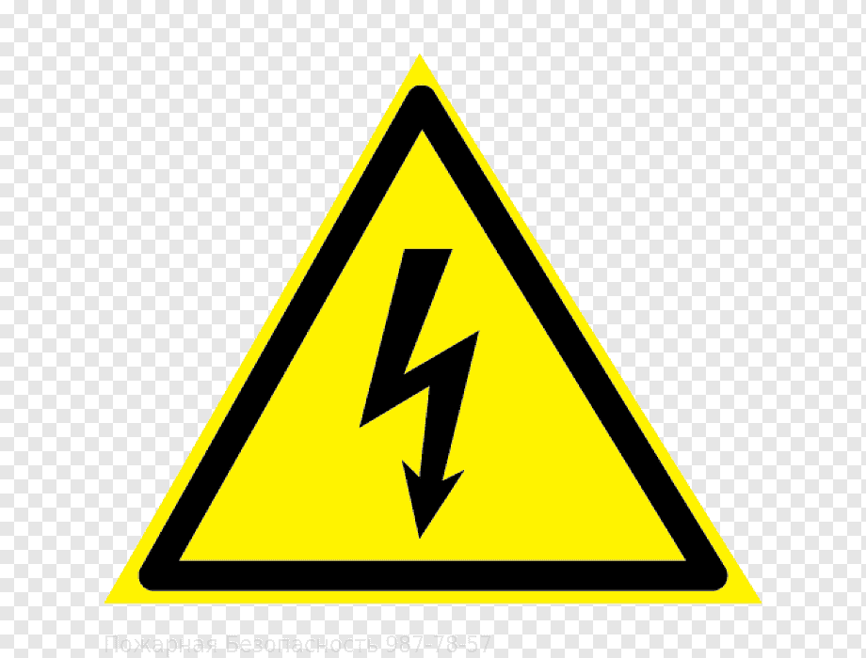 | Danger voltage tall
 | Manufacturer
 | Item not may direct thrown away to place rubbish
 | Fragile goods broken split
ss | This side facing to on
 | Alert to wet
 | Take care with Be careful
 | Number series

  - Safety Guide
Before using the device, the equipment and condition of the lights must be checked to ensure safety and security.
Make sure there are no people in the room when using the Air UV Lamp.
Shock Hazard To avoid the risk of trafo shock, this equipment must only be connected to an earthed power supply.
Explosion hazard, do not use the device in a flammable atmosphere where concentrations of flammable anesthetics or other materials may be present.
Don't look at the light UV with naked eye, please read the user manual first before using/operating the unit.
- Instruction Use
- Insert the glass sleeve into the housing tube from one end to the other until it is completely installed.
- Install the o-ring seal on both ends of the glass sleeve that has been perfectly installed on the housing tube.
- Install the housing cover on both ends of the housing tube.
- Insert the UV lamp into the tube housing through closed hollow housing .​
- Install the trafo ballast on the UV lamp with plug in the 4 pin UV lamp to in the trafo ballast socket as in the picture.
- After the UV lamp and trafo ballast are installed with perfect push insert the ballast transformer socket into in the housing tube with perfect.
- Install the UV lamp housing clamps on both sides of the housing as shown in the picture.
- Connect the trafo ballast to a 220V/50Hz voltage. If the LED indicator green on the trafo ballast can be lights up (see picture), then trafo ballast and UV Lamp declared to be functioning normally
- The hole for the incoming water channel will be sterilized or irradiated with a UV lamp.
- The hole for the water outlet has been sterilized or irradiated with a UV lamp.
- Store the unit in a safe place and out of the way from range children.
- Specification
Name |  |  | UV Water Sterilizer
Model |  |  | 40 Watt
Resource​ |  |  | Voltage 220 VAC 50Hz
Power |  |  | ±40 W
Power Factor Ballast |  |  | >0.9
Index Ballast Protection |  |  | IP65
Waterproof and Dustproof Ballast Casing With Wave |  |  | Seal With Wave Ultrasonic
Types of Sterilization with UV Lamp Types |  |  | Silicone O- rings (2 pcs)
Wavelength​ |  |  | 544 nm
Age Light |  |  | ≥3000 hours
Pressure Water flow |  |  | 0.2 MPa
UV lamp | Long |  | 86 cm
UV lamp | Diameter |  | 2 cm
UV lamp | Heavy |  | 105 gram
Sleeve | Long |  | 90 cm
Sleeve | Diameter |  | 2.3 cm
Sleeve | Heavy |  | 190 gram
Housing | Long |  | 91.5 cm
Housing | Diameter |  | 6.3 cm
Housing | Heavy |  | 2.1 kg
Housing | Material |  | SS 304
Housing | Clamp |  | Pure ABS Plastic (2 pcs)
Alarm system if happen failure within​ operation |  |  | Red visual light and sound
Net weight |  |  | ±6 kg
Operation |  | Temperature | -10 degrees Celsius ~ 40 degrees Celsius
 |  | Humidity | ≤90%
 |  | Atmosphere | 700 hPa
Transportation and Storage |  | Temperature | -20 degrees Celsius ~ 55 degrees Celsius
 |  | Humidity | ≤95%
 |  | Atmosphere | 700 hPa
- Equipment Maintenance and Repair
  - Maintenance
- Keep away from range children
- Light can broken If hit object hard and sharp , pay attention storage .
- Clean up in a way periodically so that you can maintain its effectiveness .
- Check connection light with seat lights , make sure No There is leniency , because will cause heat and fire .
- If not used in period long time, break up supply Power from PLN network.
  - Instruction Short Tool Repair
No | Damage | Possible Causes | Action
1 | Light No can light up | PLN supply is not There is  Light separated  Ballast damaged  Timer is broken | Check PLN supply  Change the light  Replace ballast  Change timer
2 | Remote no functioning | Battery remote finished  Remote button is broken | Replace the battery  Repair the button
Warning
Make sure voltage trafoity from PLN already let go before do maintenance / repair.

- Disposal remainder product
Please comply laws and regulations local for disposal remainder products, including material packaging, waste battery and product, and try follow classification and recycling repeat.
- Warranty
PT. Sinko Prima Alloy guarantees Elitech UV Water Sterilizer 40watt free from defective workmanship and materials​ during term time (2) years since date purchase. Contact your distributor or more clearly . Guarantee This limited to buyers original UV Water Sterilizer 40watt. Each part or defective assembly​ will repaired or replaced based on consideration and consideration Alone from PT. Sinko Prima Alloy if the unit is has operated with Correct during the warranty period. Normal maintenance items and components very use No covered in warranty this . Cost Send If there is, must be paid by the buyer.

PT. SINKO PRIMA ALLOY
Alamat : Jl. Tambak Osowilangun Permai No. 61,
pergudangan osowilangun permai Blok E7-E8,Surabaya-Indonesia (60191)
Telepon : 031-7482816
Fax. : 031-7482815
Aftersale (WA) : 0821-4281-7085
Email : aftersales@elitech.co.id
sinkoprima@gmail.com
Website : www.elitech.id

SPA-BM/PROD-252. 02 Desember 2025. Rev00

